Shell Commands in a Linux Environment

David Graves
Colorado State University Global
CSC507
Dr. Joseph Issa
July 19, 2025

Exploring my computer
Today’s computers come in myriad shapes, sizes, and complexity to suit the form and usage required of them but at their core most have a handful of structural components in common. These core component attributes can differ from machine to machine affecting performance and usability, so it is helpful to understand how to look up and decipher what a computer is capable of to ensure fit for purpose. I will use the remainder of this paper to explore four of these main components including the processor, main memory, I/O modules, and storage devices for my laptop. I will use shell commands in a Linux environment to return useful data about these components to understand how my machine is set up and share their purpose.
Processor
In simple terms, the processor is the brain of the computer and is responsible for executing instructions. More specifically, it “controls the operation of the computer and performs its data processing functions.” (Stallings, n.d.) The shell command ‘lscpu’ returns details about the processor architecture, number of CPUs, cores per socket, CPU MHz, cache size and other items when run in a Linux environment. As shown across Images 1a and 1b below, my computer has 4 CPUs clocking at 1.10GHz, with four instances of cache across three levels with varying KiB sizes as seen below.
Image 1a (Processor Detail)
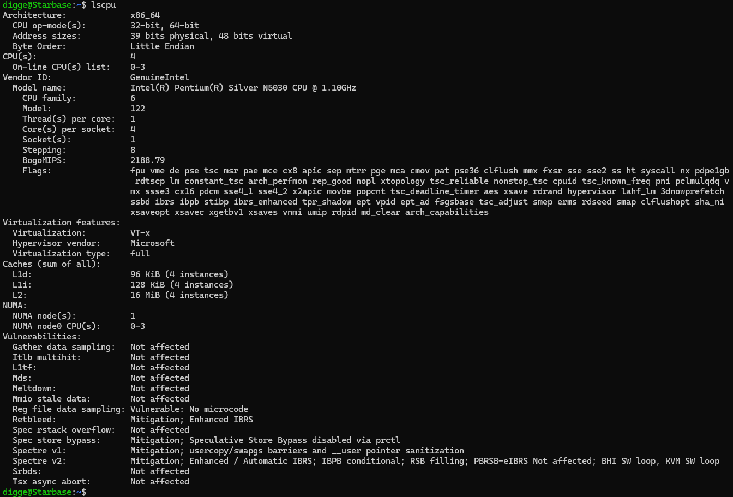
Image 1b (Processor Detail)
Main Memory
The second key component to consider is the main memory on my machine. The main memory is a type of memory that stores data and programs “serving as the intermediary between the CPU and the long-term storage devices.” (Staff Writer, 2025) It is a key component in helping the computer function efficiently where its speed and size directly affect performance. The shell command ‘free -h’ returns the total RAM as well as other details of my computer. As shown below in Image 2 my computer has 15Gi total RAM with 511Mi currently in use with 4.0Gi available as an extension via Swap if I put enough stress on the system where it would eat up the available 15Gi and require additional space.
Image 2 (Memory)
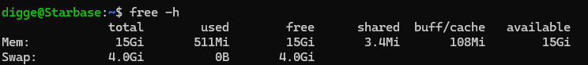
I/O Module
The I/O Module, also known as Input/Output Module, is another key component of the core system that helps with communication between the CPU and its external environment. It does this by connecting the “processor’s system bus to one or more peripheral (input/output) devices… where it manages data transfer, controls power loads, and manages machine instructions.” (Medewar, 2025) I can see what current devices and their drivers are on my machine by running the ‘lspci’ command in Linux command prompt as shown below in Image 3.
Image 3 (I/O Module)
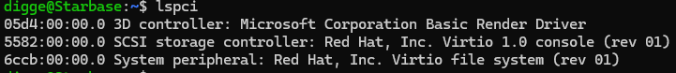
Storage Devices
The last key component to explore is the storage devices associated with my computer. These do exactly what they say they do in that they are essential for storing and retrieving data. I can see these devices by running the ‘lsblk’ command in Linux as shown in Image 4 where it displays the devices and attributes such as number, size, and type. Doing that, I see that I have four total disks that contain over 1T in storage across the entire system and that these are all disks rather than partitions.
Image 4 (Storage Devices)
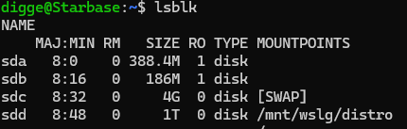
Reflection
This was my first experience using Linux as an operating system and I found it straightforward. I have previously found this type of component critical information via ‘my computer’ under the settings application in Windows, and I am happy to learn these new commands to see this in Linux now. It is also great to start working to become comfortable in the Linux environment, which is more agnostic than Windows and supports a wide range of programming languages. This exercise showed that I can find more granular details about how my specific computer is set up which should serve me well to understand for this class and down the road while broadening my understanding of operating systems.

References
Medewar, Sameeksha (2025, Feb 11). Techgeekbuzz.com. I/O Module: An Interface Between the
CPU and I/O Devices.
https://www.techgeekbuzz.com/blog/io-module/
Staff Writer (2025, May 14). LaptopJudge.com. What is Main Memory of a Computer?
https://laptopjudge.com/what-is-main-memory-of-a-computer#:~:text=Main%20memory%20serves%20as%20the%20intermediary%20between%20the,from%20the%20storage%20device%20into%20the%20main%20memory.
Stallings, W. (n.d.). Operating Systems: Internals and Design Principles, 9/e.
Retrieved from: https://platform.virdocs.com/read/2228445/13/#/4/2[P700101386900000000000000000050D]/2/2[P700101386900000000000000000A4C8]/2,/1:0,/1:0

